Name of the Event: - Workshop on FRA Implementation & Forest Governance in Jharkhand
Date: - 24th & 25th June, 2022
Venue: - Saptrishi Sewa Bhawan, Tupudana, Ranchi
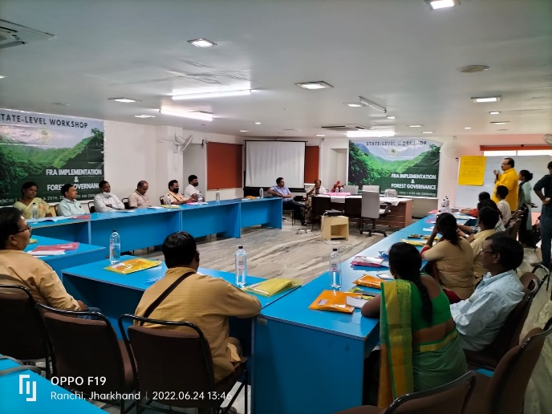
A state level workshop to prepare the road map and to design the strategy on FRA (Forest Rights Act) implementation and forest governance in context of Jharkhand was held on 24th and 25th June, 2022 at Saptarishi Seva Bhawan, Tupudana, Ranchi. About 35 CSO representatives and individual dignitaries working in this sphere from across the state marked their presence in it to discuss and formulate strategy for IFR (Individual Forest Right) as well as CFR (Community Forest Right). FES and PRADAN jointly collaborated to take up this cause of vital importance. Discussion on SOP was done and an update on its progress so far was done. Last meeting minutes were also discussed and the concerned problem statement were also reflected upon to prepare the road map ahead.

